************Back-end********************

Before Initialize please go to application properties and change the username(line 18) and password(line 19) .

Src/main/resources/application.properties.

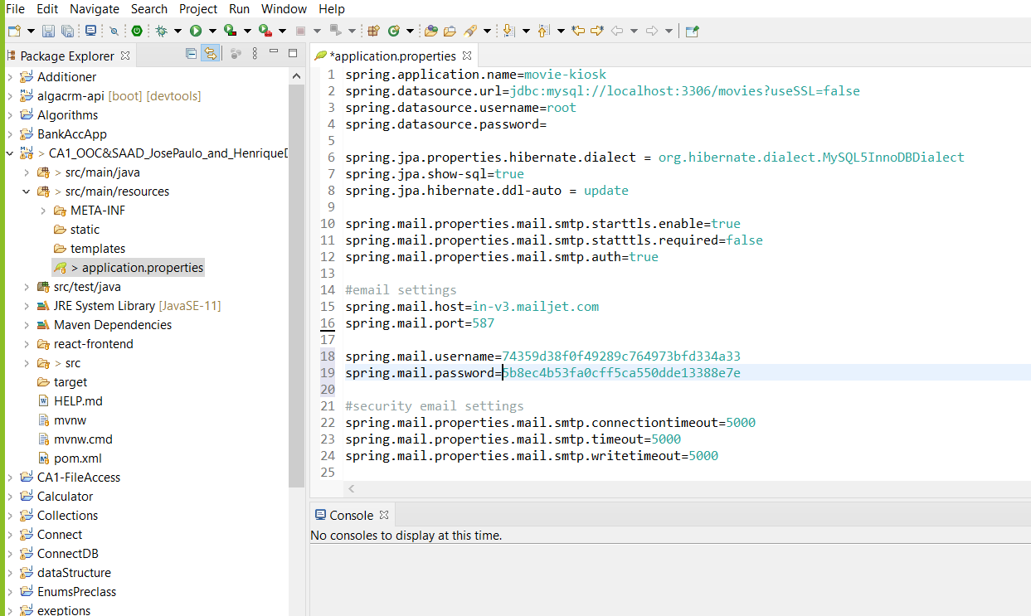

Just paste the username like the picture above without the arrow

=>74359d38f0f49289c764973bfd334a33

And password: without the arrow

=>5b8ec4b53fa0cff5ca550dde13388e7e

GitHub Repo:

https://github.com/Josep1990/xtravison_ca1.git

initialize the application using spring boot

*********** Front-end ******************

Before start the application open the front end folder in visual studio code.

cd to front_end.

type this command (Make sure that you have node.js installed on your machine.)

npm install

then:

npm start

If the application do not open type localhost:3000 on the browser